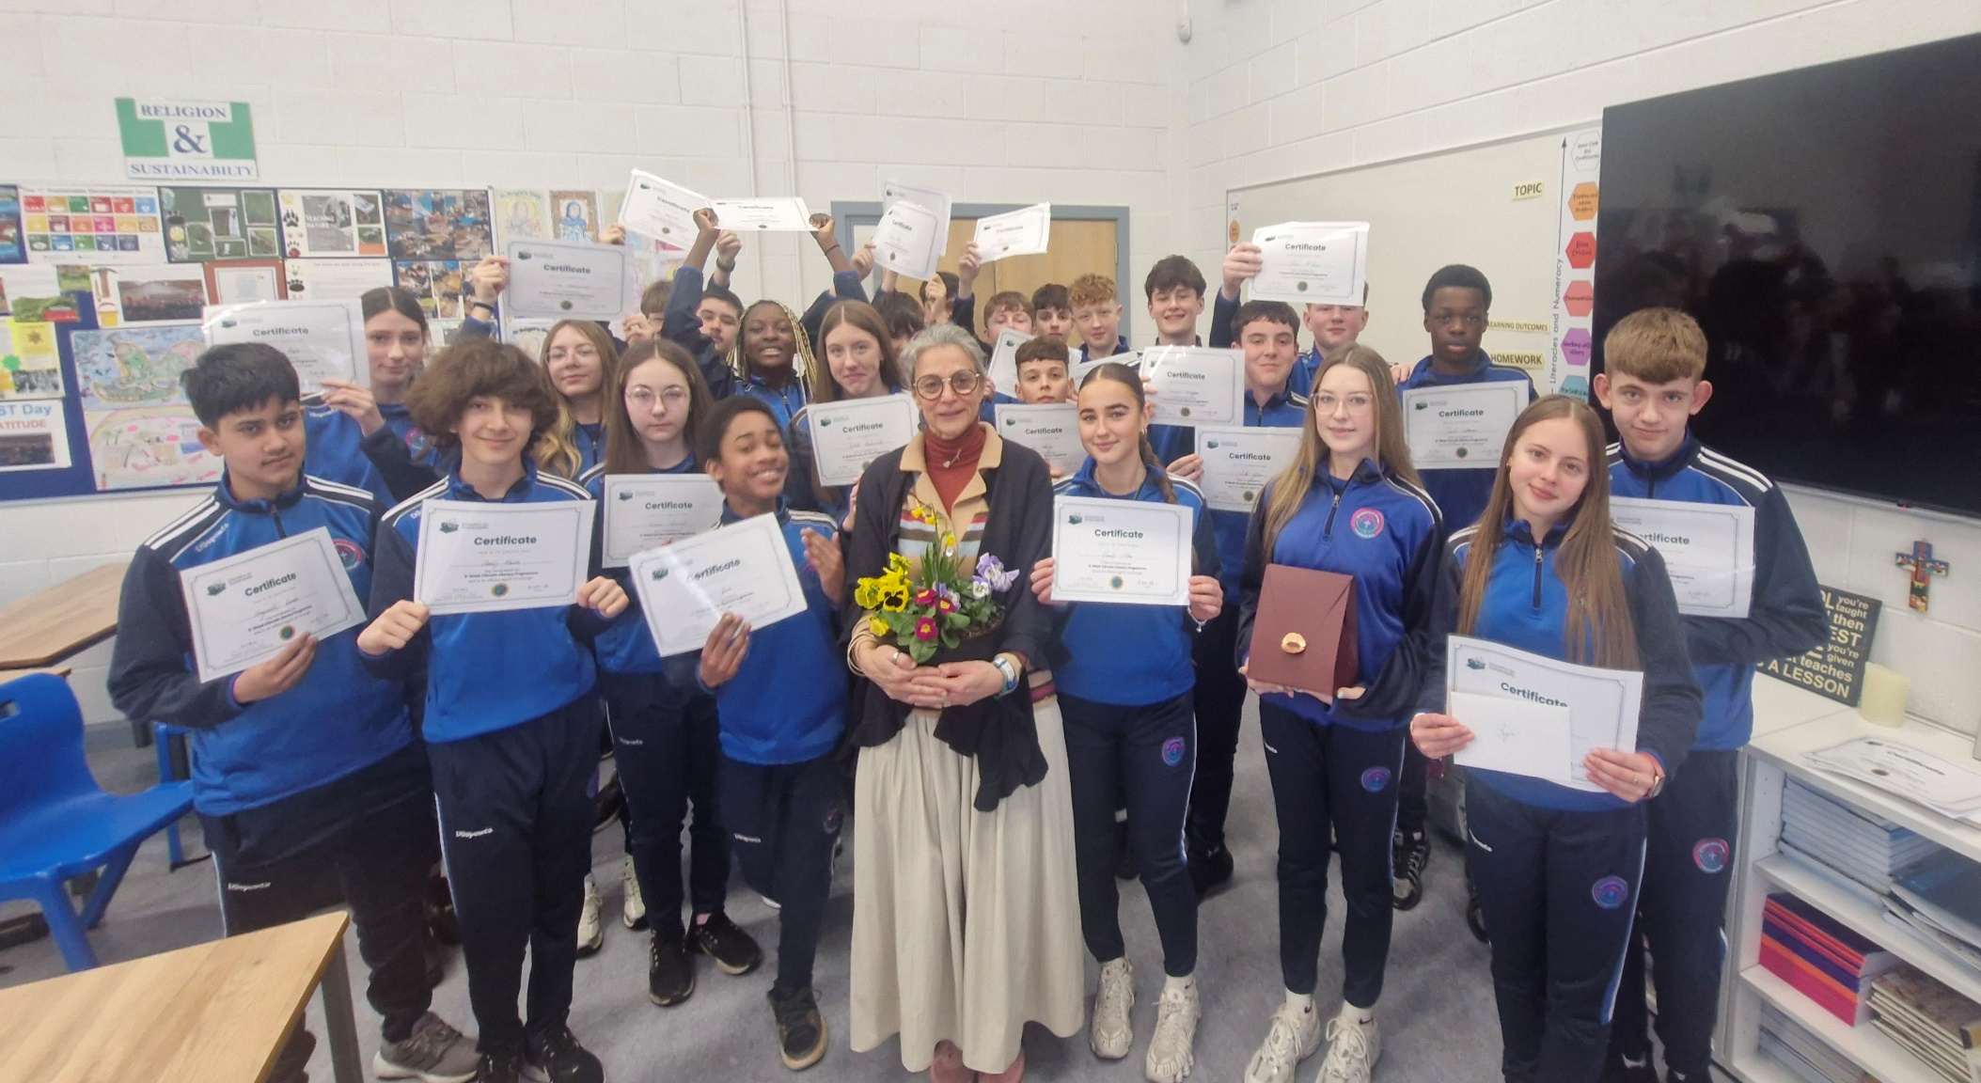
Sanja Dunne from ‘Education in Sustainability’, being presented with gifts from Ms Kelly’s Second Year group who completed a Climate Literacy Programme over eight weeks. The students were actively involved in learning how to build solid foundations for a more sustainable future for all through education and action. The students are pictured here with their well-deserved Certificates.
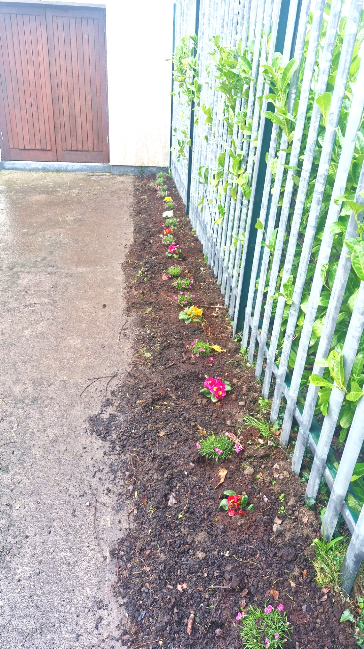
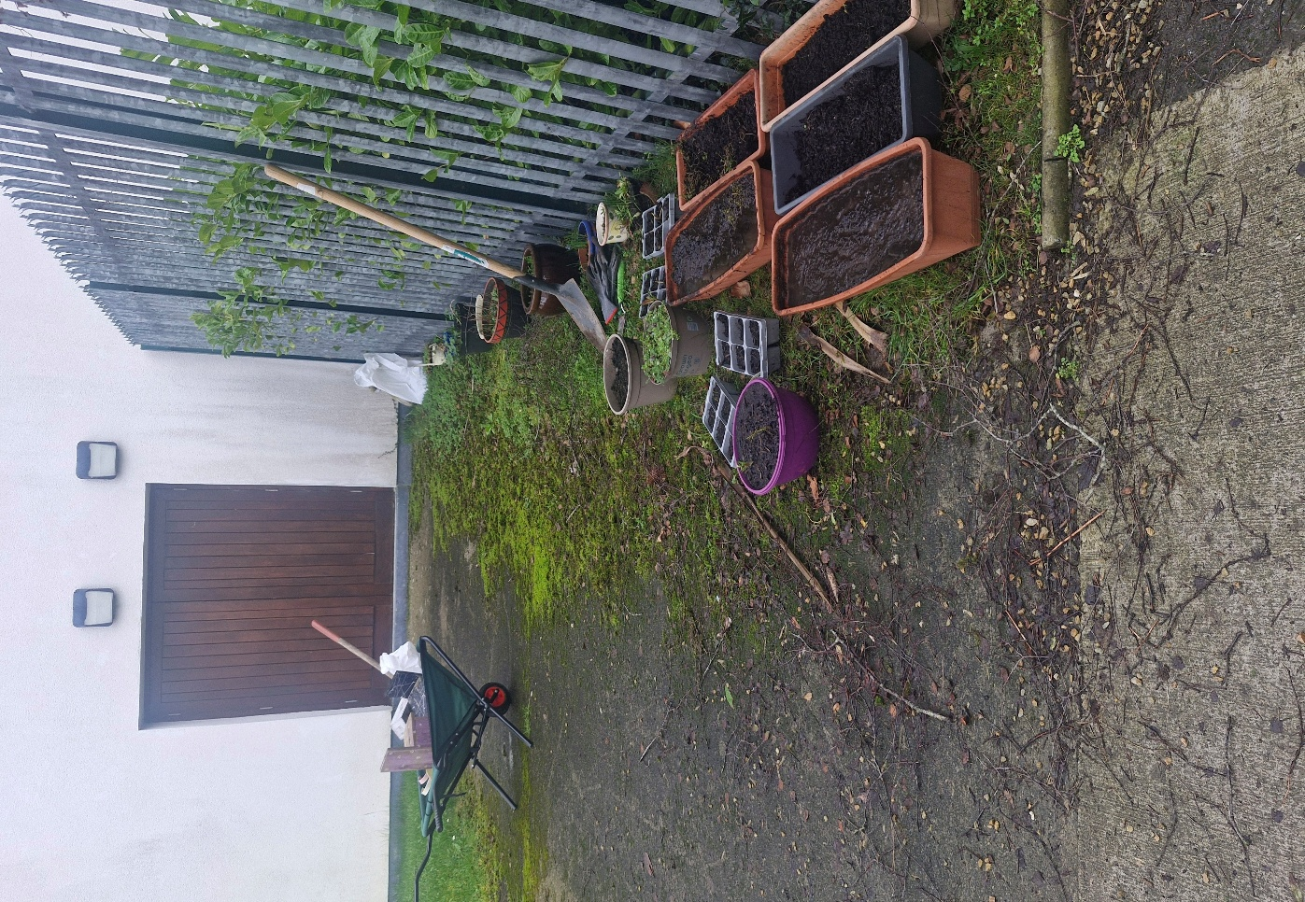
BEFORE AFTER
Ms Kelly’s Religion classes jointly worked on this project to clean up and create an aesthetic space for Biodiversity in the school.
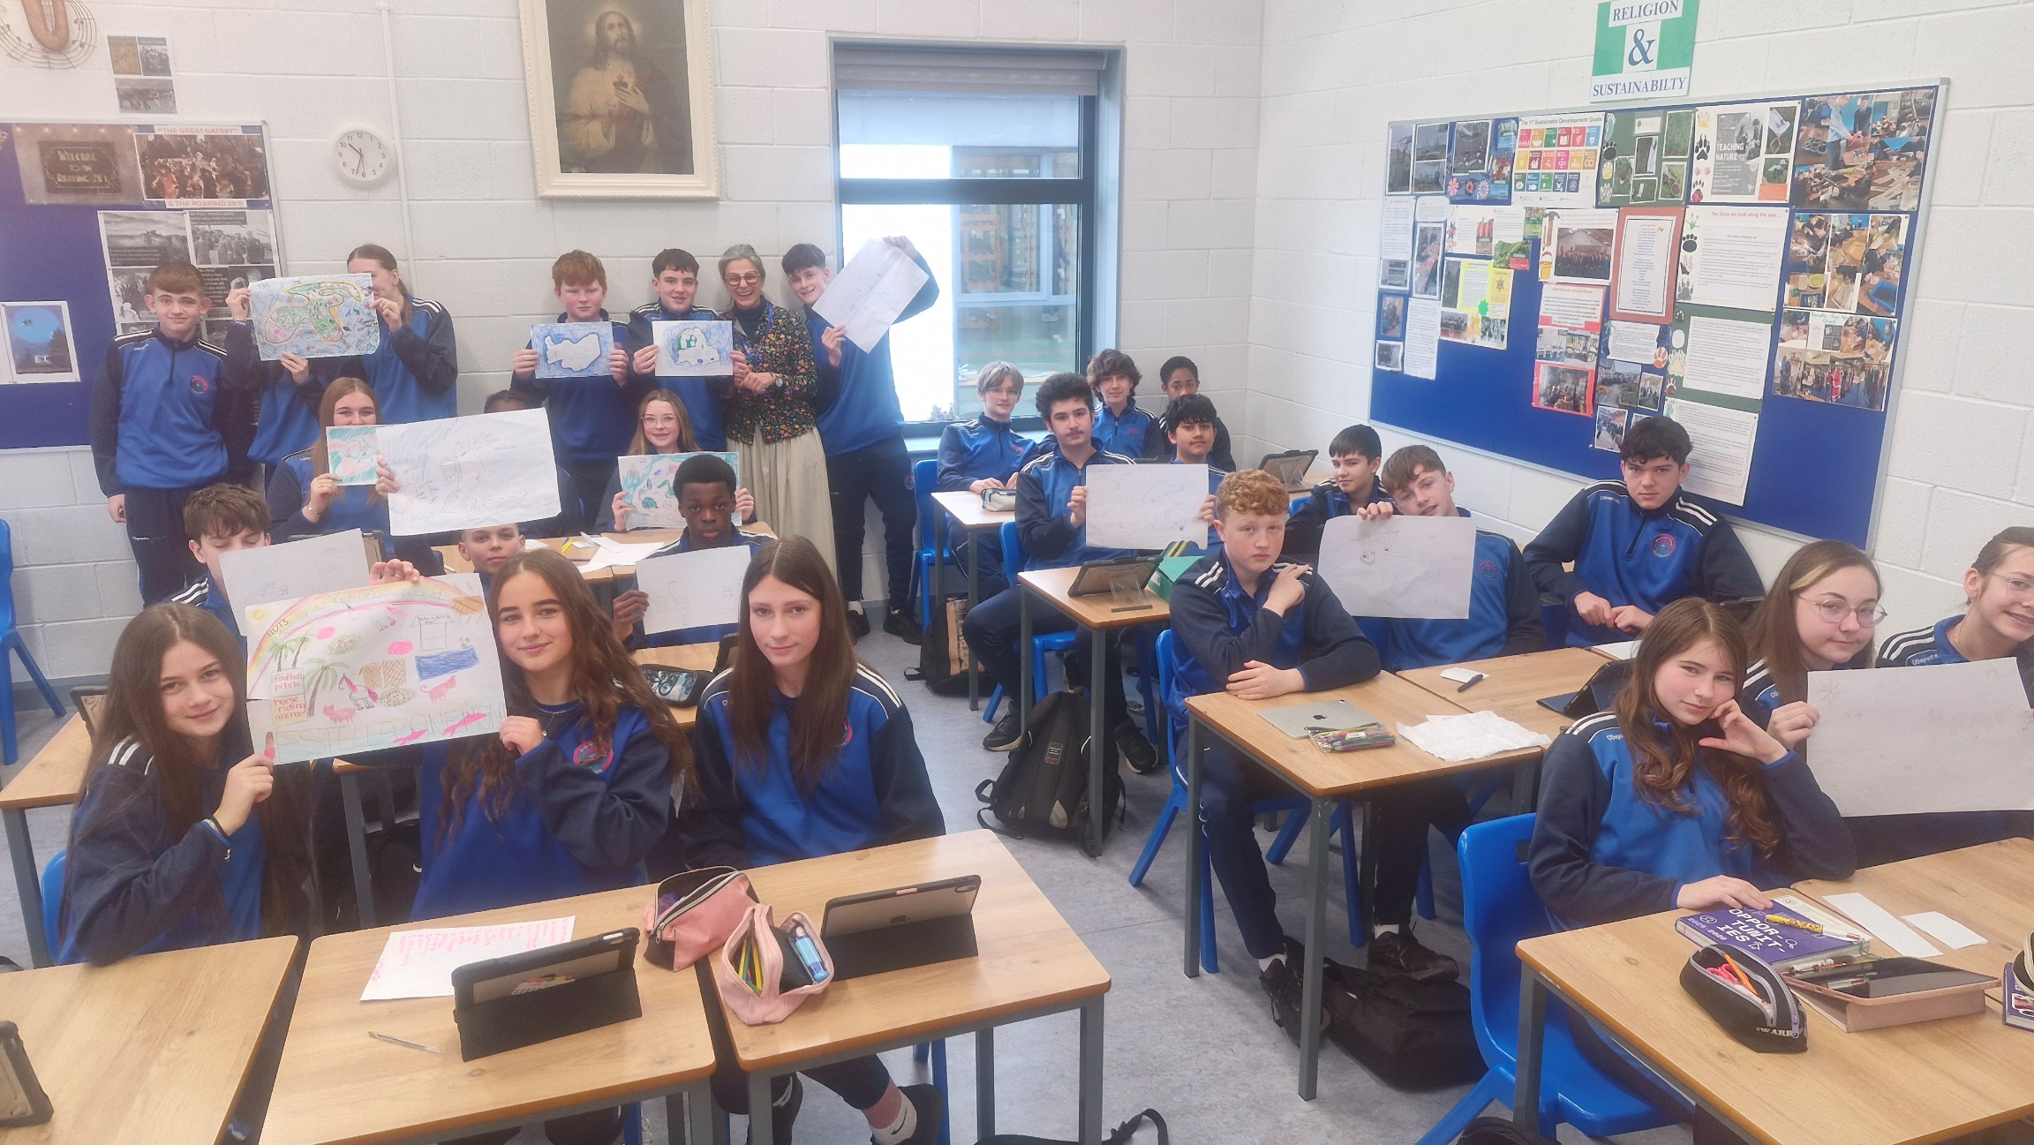
The students created their own Sustainable Island: the creative activity encouraged them to think about their island’s use of energy, transport, waste management, transport, social needs, education, health and clothing requirements.
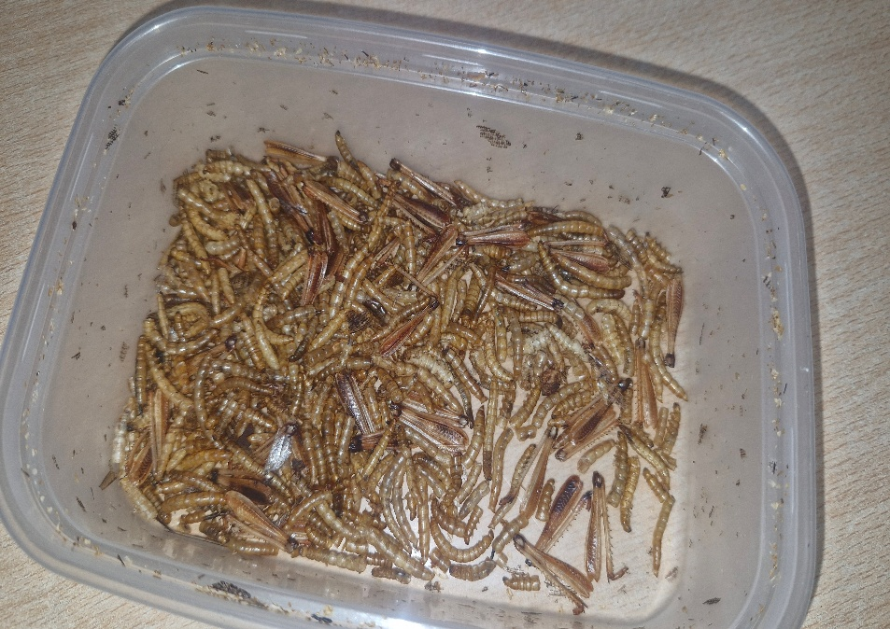
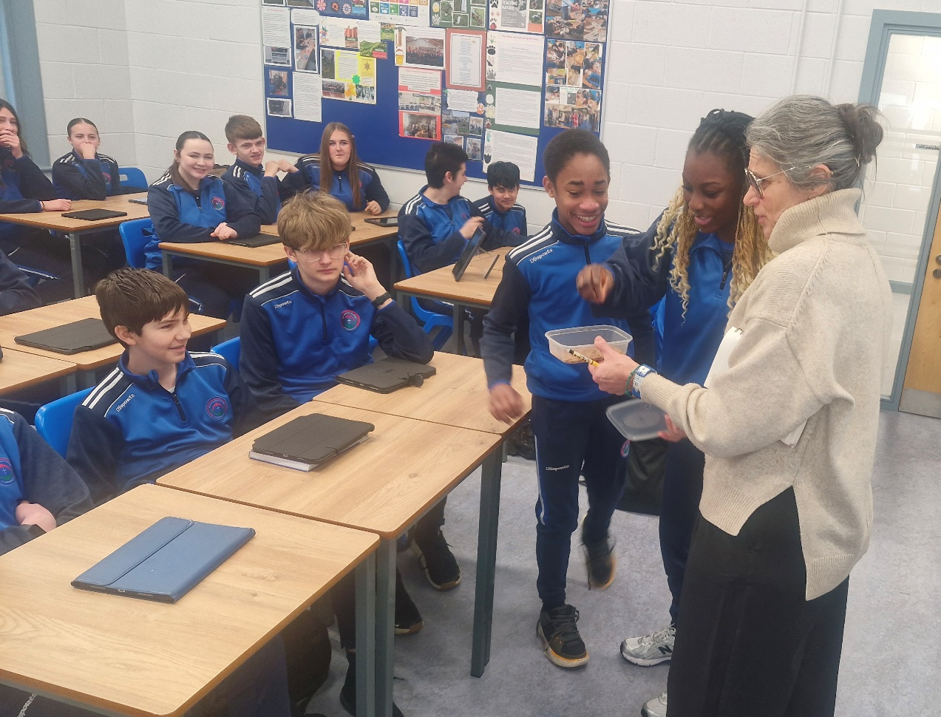

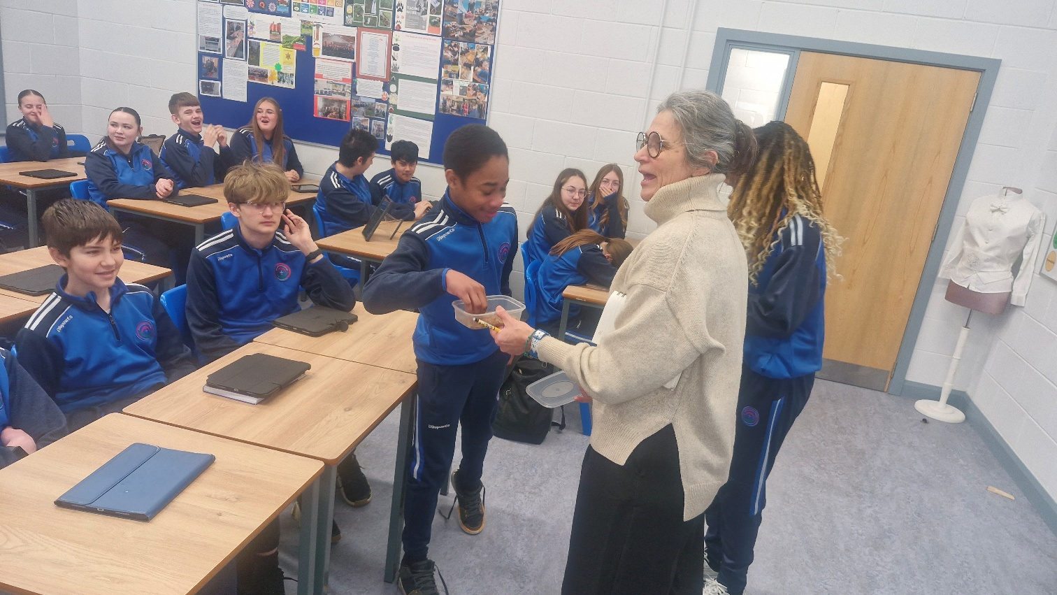

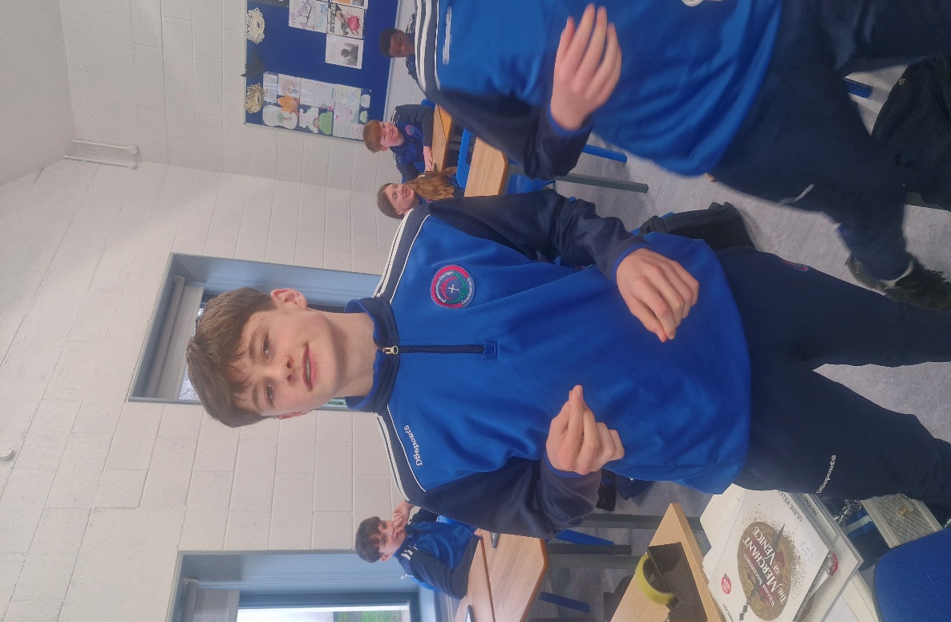

Some of the students who bravely took on the challenge of eating, ‘MEALWORMS’!
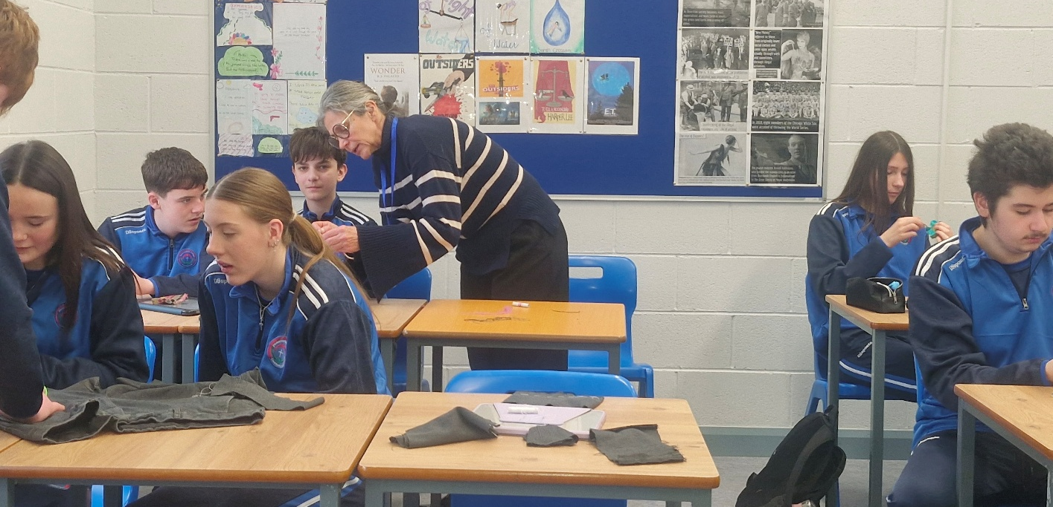
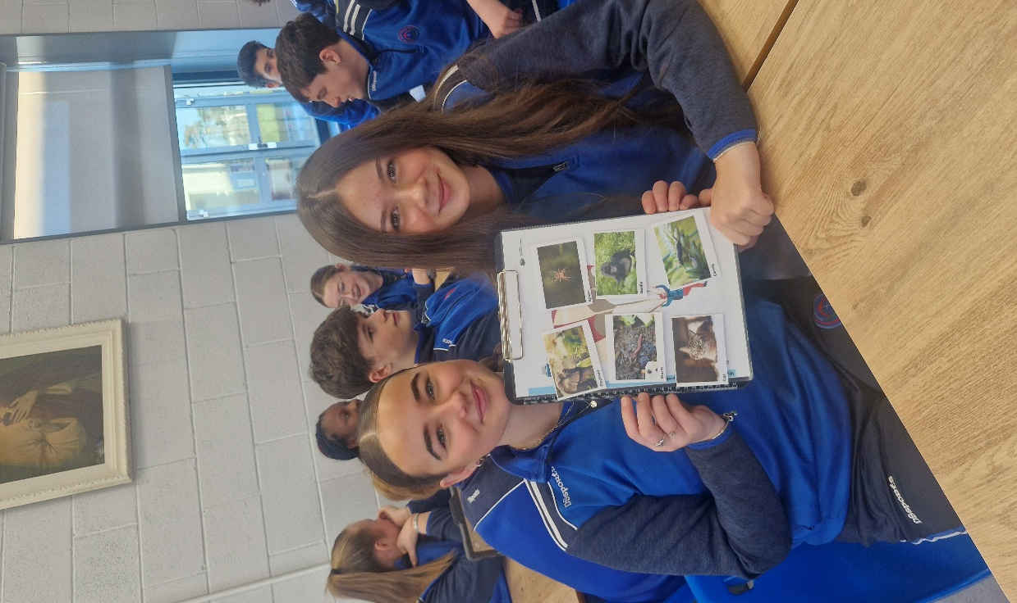

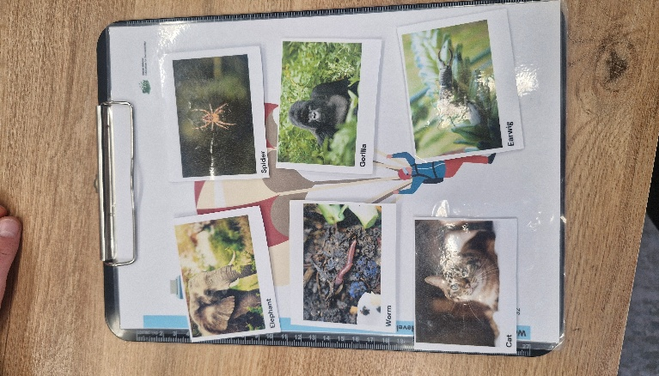

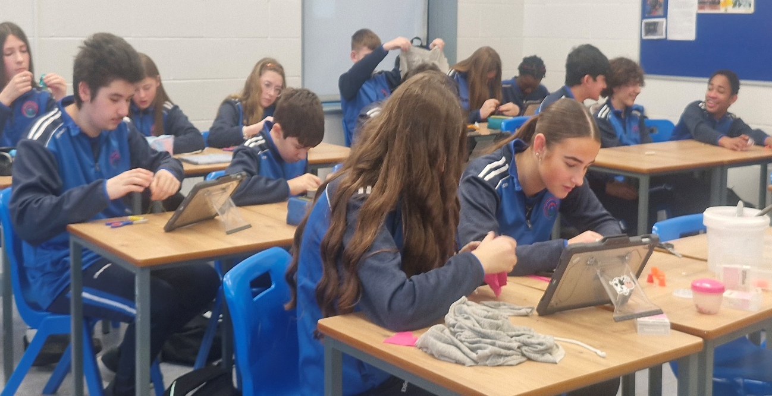

Students busy sewing animals they created from
scrap material.

